Name: Aqueno Amalraj, Minna Chae, Sarah St. Albin

TCSS 502

Dungeon Adventure: Output

Output Capture

Winning Scenario for default mode (Easy):

MAZE GEN default mode (Easy->5\*5)

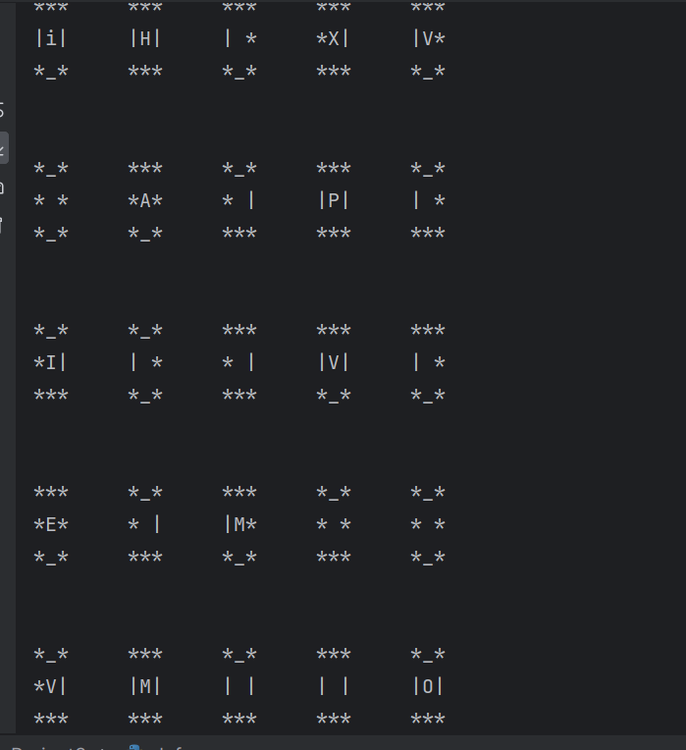

Winning output:

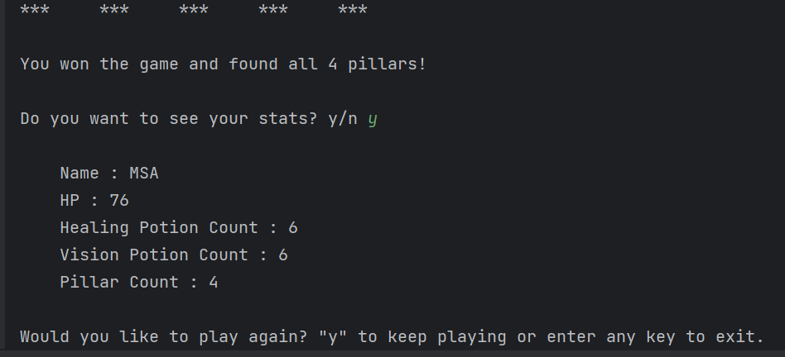

Losing output:

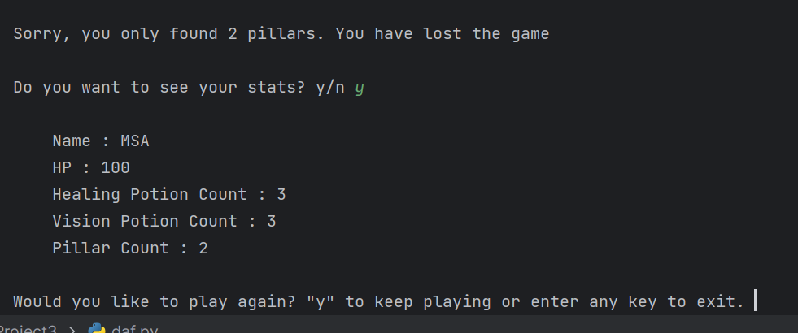

MAZE GEN (medium –> 10\*10):

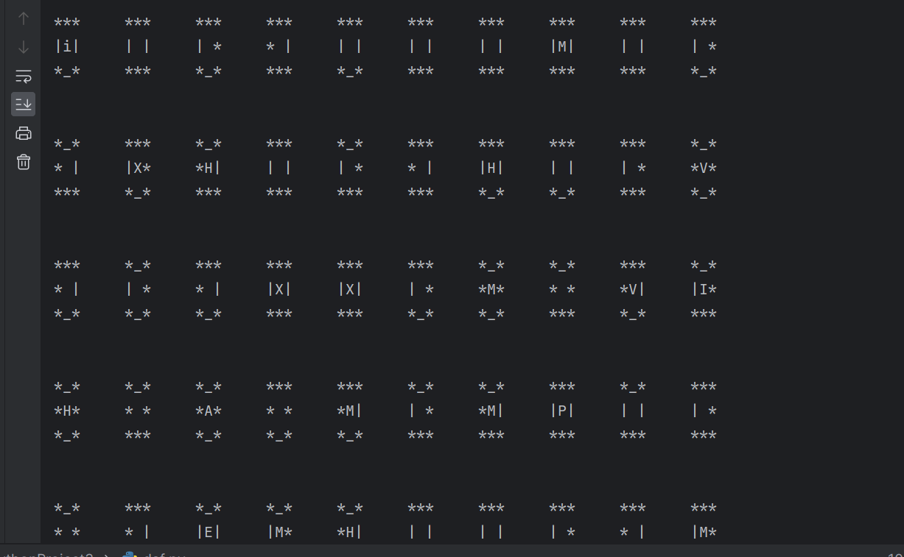

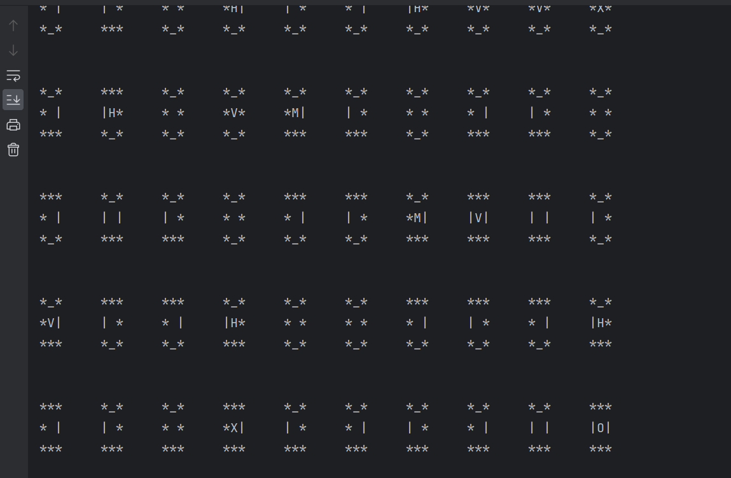

Winning scenario user choice (medium):

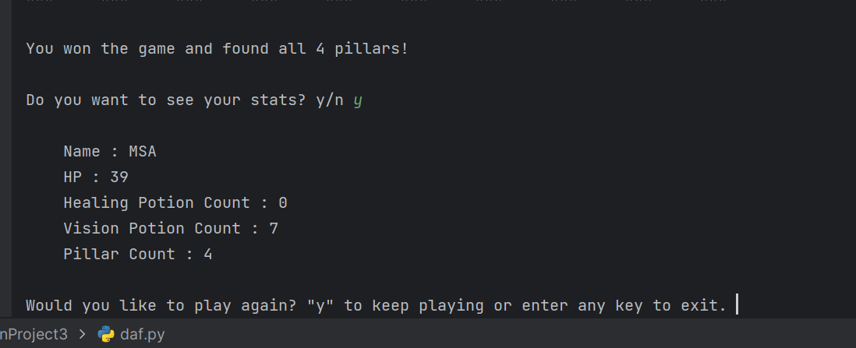

Losing scenario user choice (medium):

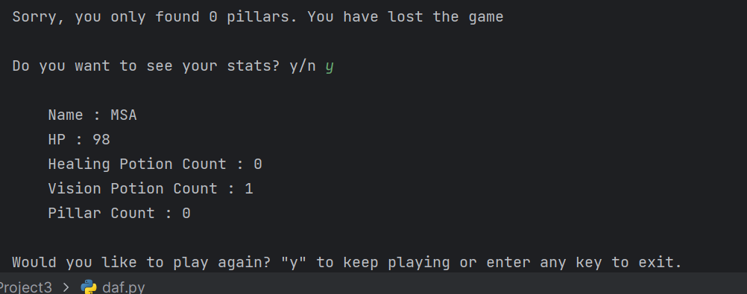

Losing due to health points being less than or equal to 0

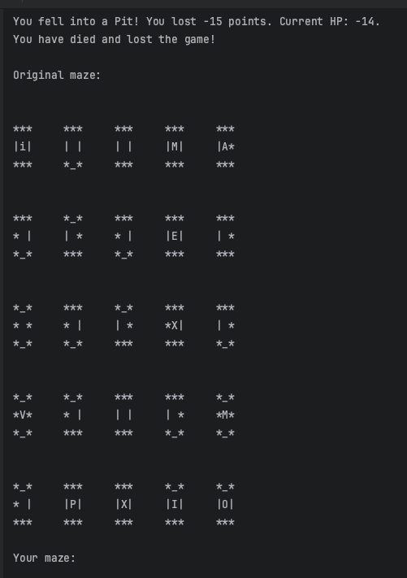

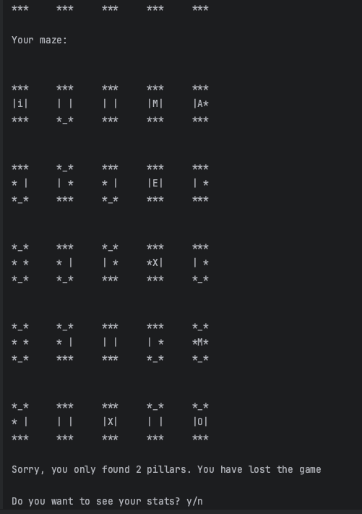

Usage of Vision Potion:

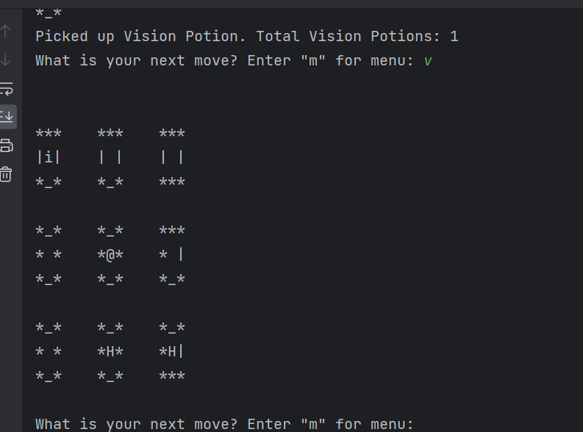

Usage of Healing Potion:

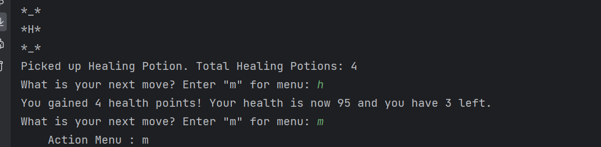

Added feature: After next move is successful, a print out of the maze, player area previously traveled, player area not yet traveled is differentiated plus the print of the new current room with all doors and found item

